Tips for Choosing Accessible Resources
The information below is provided as a guide for common resources that are used in the course development process. It is important to keep in mind that each individual resource is unique and, while general guidance is shared below, each resource will be reviewed to ensure it is accessible.

Resource Examples
Resource Type | Typical Usage in LMS | What To Look For | Accessibility Action
YouTube or Vimeo Videos | Linked or embedded into modules, pages, or assignments for lectures or supplemental content. | If the caption and transcript are in all lower cases and do not contain appropriate upper- and lower-case letters, the video does not meet accessibility requirements.  If the captioning and transcription do not contain proper punctuation, it does not meet accessibility requirements.  Multimedia Accessibility Checklist | If hosted on an internal channel, they require accurate captions and transcripts with audio descriptions, if necessary. Verify captions and transcripts; if inaccurate or missing, provide an alternative transcript or replace the video.  If not owned by your institution, changes, edits, or additions cannot be made to captions and transcripts to meet WCAG requirements.
Publisher or OER PDFs | Linked as readings or downloadable resources. | Run the Accessibility Checker in Adobe Pro. This will provide a report if accessibility issues are found.  Also, review the document for any copyright statements or Creative Commons licensure.  PDF Accessible Document Information | If editing is allowed (check licensing and copyrights), fully remediate (tagging, reading order, alt text). The ability of the accessibility team to remediate will depend on the complexity of the remediation.  If not editable, request an accessible version from the publisher or replace.
PDFs Created by Faculty | Lecture notes, resources, and assignment instructions. | PDF Accessible Document Information | Remediate within the institution to meet WCAG requirements: tag structure, correct reading order, alt text for images, proper headings, and language setting. The ability of the accessibility team to remediate will depend on the complexity of the remediation.
Third-party Websites | External articles, tools, case studies, etc. | Please refer to the Web Accessibility page and the Web Accessibility Checklist. | We cannot remediate external sites. We do not own them or have access to remediate.  If they do not meet WCAG requirements and pose major barriers (ads, etc.), we will explore alternative sites, UDL language, or the creation of fact sheets in partnership with faculty to ensure students have the needed content.
Media | Institution created and uploaded video/audio for lectures or announcements. This also includes media requested for student submissions. | Please refer to the Multimedia Accessibility Guide page for information on captioning, transcripts, and a checklist to quickly use while evaluating media. | Provide accurate captions and transcripts. This will be done as part of the creation process.
Word or Google Docs/Slides/Sheets | Linked as collaborative assignments or shared resources. | Please refer to the Creating Accessible Content site and also a guide to learn how to use the Accessibility Checker built into Microsoft products. | Use the built-in accessibility checker, apply proper headings, alt text, and share with edit/view permissions to maintain accessibility. Export as an accessible PDF if needed.
Third-party LTI Tools | Tools/applications like Amplifire, ExPrep, or external quizzes. | Please reach out to your institution’s Accessibility Team for third-party tool accessibility checks. | Ensure vendor VPAT/ACR aligns with WCAG 2.2 AA. Review and test the tool to ensure it is WCAG compliant and include accessibility requirements in procurement contracts.  If the tool does not meet accessibility requirements, a meeting with the vendor (if possible) is necessary to determine if compliance can be reached and the timeline for the effort.
The checklists and sites mentioned above are available at the University of Arizona Global Campus Accessibility Resource Center.
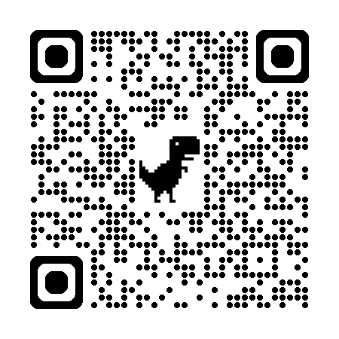

Steps for Determining Remediation or Resource Replacement

Step 1: Determine Ownership or Control
Question: Do we own the content or control it through a contract?
Owned examples: LMS pages, university websites, PDFs created by your own institution, Word documents, PowerPoint files, media hosted on our servers, SCORM or Articulate modules created by the institution.
Controlled by contract: Licensed tools or content with clear accessibility obligations in the contract.
- Action: If Yes, we can remediate to meet WCAG 2.2 AA. This includes captions, transcripts, keyboard navigation, alt text, contrast, reading order, and all other applicable success criteria. Document testing and fixes.
- If No, proceed to Step 2.

Step 2: Check for Accessible Equivalent
Question: Is there an accessible equivalent resource that meets the same learning objective?
Examples:
- A captioned version of a video on another platform.
- An accessible HTML version of a PDF.
- A different but equivalent article or dataset.
Action: If Yes, use the accessible equivalent and document the substitution.
If No, proceed to Step 3.

Step 3: Determine Essentiality
Question: Is the resource essential to meet a required learning objective or assessment?
Consider:
- Does it support a core competency or outcome?
- Is it mandated by curriculum standards or accreditation?
- Is it unique and not replaceable?
Action:
• If No: Replace it with an accessible replacement that achieves the same objective or remove it.
• If Yes: Replace with an equally effective replacement (example: Fact Sheet). Please consult
with your institution’s Accessibility Team or Library Services regarding options.

