Hey! Thanks for coming to my session. Here a bonus for you!
This is the list of ALL of the amazing tools we’ve been talking about and that others have discovered as well.
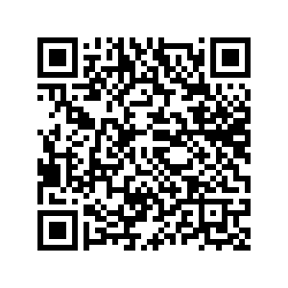
https://docs.google.com/document/d/1gVnixZo-JCW8LEixM1fHFcpCi3E6-yKnLMSAlj-qqOA/edit?usp=sharing

Enjoy! Make awesome things.

-Steve
skaufman@uakron.edu

