HTML Accessibility Code Examples

Headings
<h1>Main Page Title</h1>
<h2>Section Heading</h2>
<h3>Subsection Heading</h3>

Lists
Unordered (bulleted) List
<ul>
<li>First bullet item</li>
<li>Second bullet item</li>
</ul>
Ordered (numbered) List
<ol>
<li>First step</li>
<li>Second step</li>
</ol>
Ordered (numbered) List Starting at 3
<ol start="3">
<li>Third step</li>
<li>Fourth step</li>
</ol>
Unordered (bulleted) List with Alpha Labels
<ol type="a">
<li>Option A</li>
<li>Option B</li>
</ol>

Meaningful Links
<a href="https://university.edu/accessibility">View Accessibility Resources</a>

Images and Alt Text
<img src="lab.png" alt="Student using microscope in a biology lab">
For Decorative: <img src="divider.png" alt="">

Tables (caption, header, border, padding, width)
<table style="border: 1px solid #000; border-collapse: collapse; width: 100%;">
<caption>Course Credit Hours</caption>
<thead>
<tr>
<th style="border: 1px solid #000">Course</th>
<th style="border: 1px solid #000">Credits</th>
<th style="border: 1px solid #000">Department</th>
</tr>
</thead>
<tbody>
<tr>
<td style="border: 1px solid #000; padding: 6px;">ENG 101</td>
<td style="border: 1px solid #000; padding: 6px;">3</td>
<td style="border: 1px solid #000; padding: 6px;">English</td>
</tr>
<tr>
<td style="border: 1px solid #000; padding: 6px;">MATH 110</td>
<td style="border: 1px solid #000; padding: 6px;">4</td>
<td style="border: 1px solid #000; padding: 6px;">Mathematics</td>
</tr>
<tr>
<td style="border: 1px solid #000; padding: 6px;">BIO 120</td>
<td style="border: 1px solid #000; padding: 6px;">4</td>
<td style="border: 1px solid #000; padding: 6px;">Biology</td>
</tr>
</tbody>
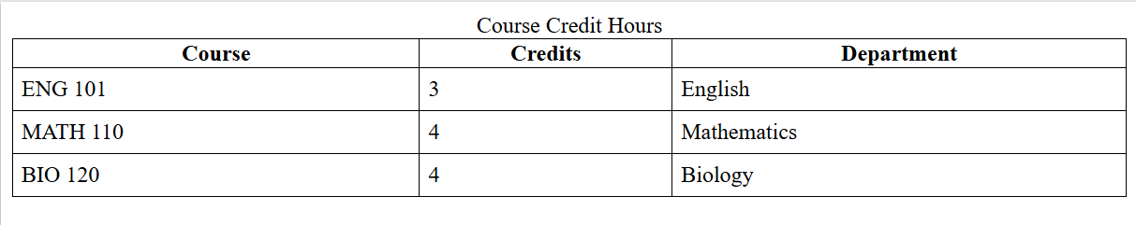
</table>

